**Manual Upgrade process for IMC standard edition**

**Pre-requisites:**

1. IMC appropriate patches for the current version has to be downloaded.

2. Patches which has been downloaded has to be moved to appropriate folder.

3. The patches will be in zip format, unzip the patch.

Command: unzip patch-name

**Upgrade:**

Open mobaxeterm on your system(moboxeterm is a software used to view the VM’s which are installed on KVM).

Go to Sessions-> VNC and provide appropriate credential to login to the KVM host.

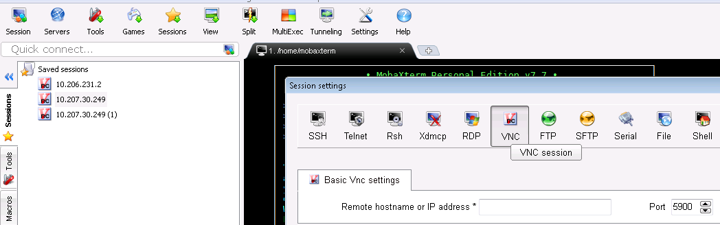

Note:

1. Before going to this terminal we have to run the command **vnc4server** where we will get port number which has to be given to the port.
2. If we run the command **vnc4passwd** it will prompt for password please provide required password.
3. Both the command has to be run on KVM host.

Give the command virt-manager

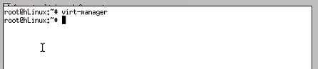

And a console will be open, where we can see all the Virtual Machines which are installed on that KVM host for eg.

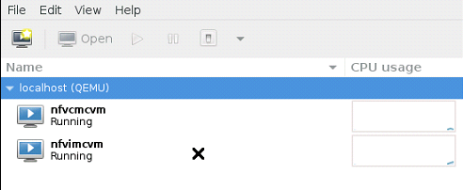

Click on IMC and press on open.

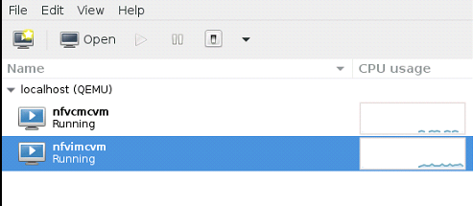

We can see the following console.

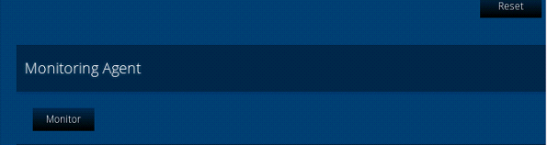

Press on Monitor, can see the below console.

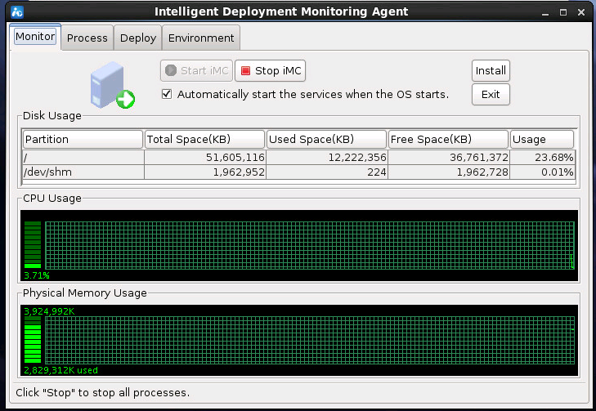

Click on install, we would get the following screen.

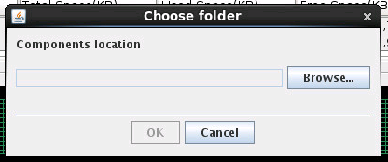

Go to appropriate folder where we have the **component folder**

**Note:** usually it will be in /linux/install folder.

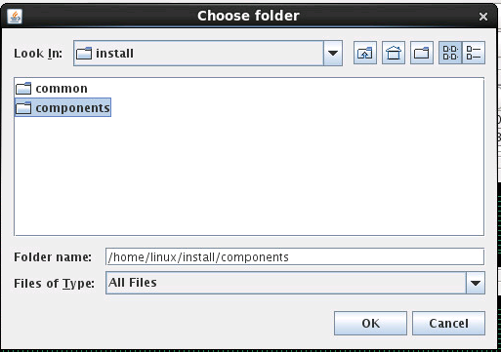

Press OK

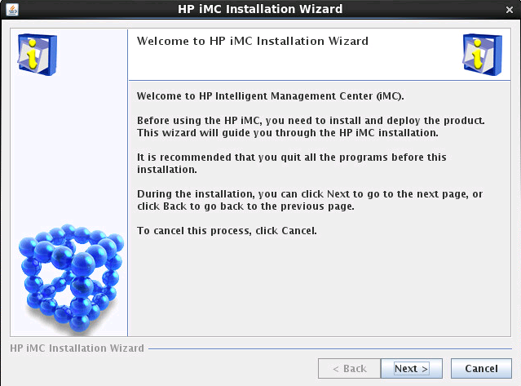

Press next.

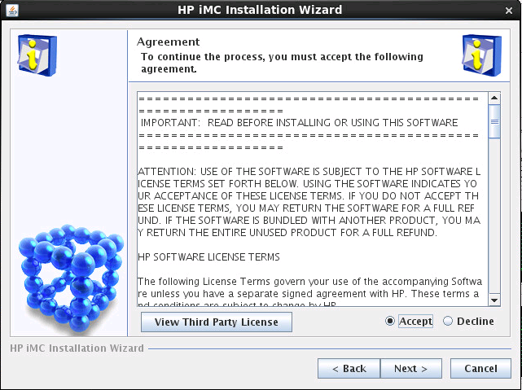

Accept the license and press Next.

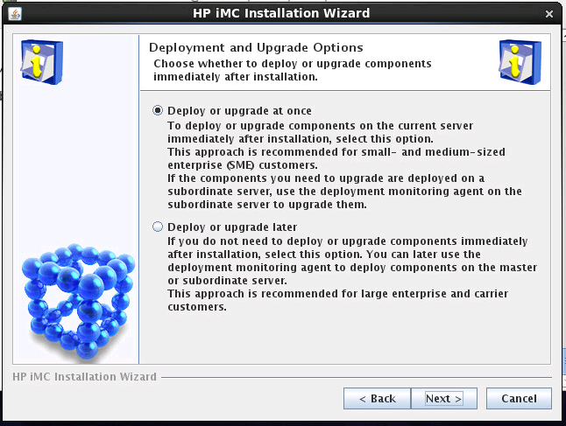

Choose Deploy or upgrade at once and press next.

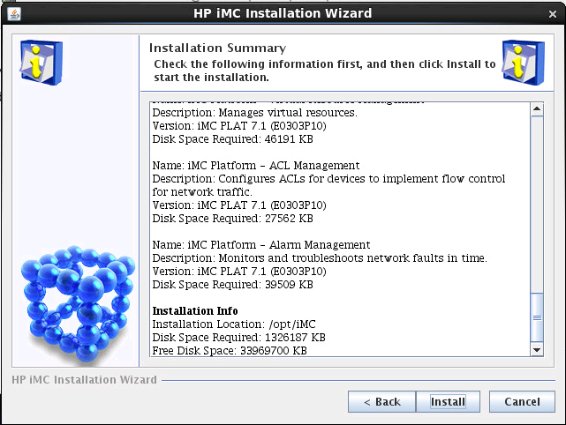

Press Install.

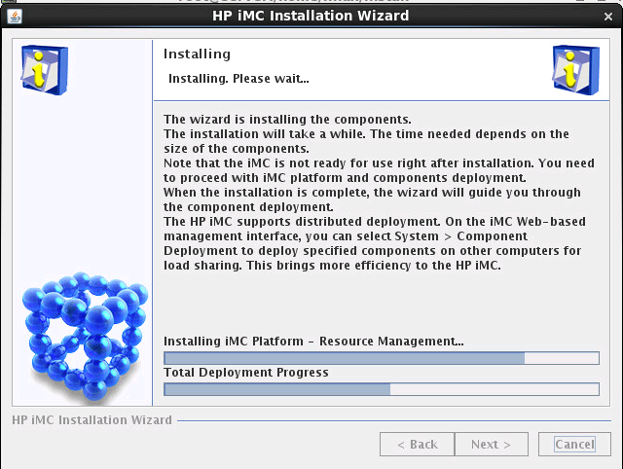

If you get the above screen your installation of upgrade is going through.

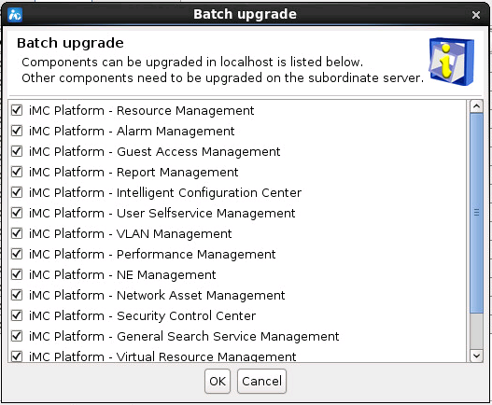

Those are the following batch upgrade that can be done choose which all upgrade is required and press OK.

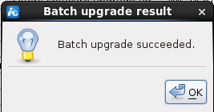

Once upgrade is done we will get the above screen.

Current version which we have installed: iMC PLAT v7.1 E0303 Standard - Linux

Current patch which is available: iMC PLAT v7.1 (E0303P13) – Linux

**Enhancements released in IMC PLAT 7.1 (E0303P13)**

• The 3D room provides basic lighting elements such as point lighting and tube lighting.

• Elements in the 3D room support automatic alignment.

• In the 3D room, the Save buttons for rooms and racks provide Successfully Saved messages.

• The 3D room supports the query function.

• Adding the text label element for the display tiling. The text label element supports entering single-line text in the text label or text field.

• Supports EAPI interfaces used for querying iMC license information.

• Supports EAPI interfaces used for querying device additional information.

• The monitoring settings page provides the instance view switch link that allows users to access the instance view page.

• The Alarm > Trap Definition > Device Severity page provides the link that allows users to access the device trap level rule page. When custom trap level rules have different devices but have the same trap, same parameters, and same level, these custom trap level rules are displayed in a rule.

• The advanced query on the Alarm > All Alarms page supports multiple query criteria, and supports AND and OR relationships between the query criteria.

• The device panels of S10500 and S12500 switches support power supplies and fans with colored borders. The border color of a power supply or fan indicates the current status of the power supply or fan. The color of green indicates that the power supply or fan is working correctly. The color of red indicates that the power supply or fan is faulty. The color of grey (no border) indicates that getting the status of the power supply of fan failed (unknown status).

• When the status of a device alarm or link alarm becomes red, the device icon or the link blinks.

• On the performance instance threshold page, the value ranges of start and end values are optimized.

• For a single index in a single performance, the default maximum number of instances is increased to 150.

• On the SMSC settings page, serial number registration for the SMS Center sending method supports entering keys.

• LiveUpdate URL changes to <https://h10145.www1.hpe.com/web/services/pcm3/PcmWebSvc.asmx>.

**Resolved Problems in IMC PLAT 7.1 (E0303P13) patch**

1. Operation logs are not recorded when you add, delete, or modify the dashboard view.

2. The Y-axis names of the monitoring charts are not completely displayed when you view the realtime performance monitoring page on the IE11 browser.

3. The GSM modem name is incorrectly displayed when you view the GSM modem configuration on the SMSC settings page.

4. Data is incorrectly displayed when you add multiple performance views in a single view of the dashboard.

5. A page error occurs when you save devices for which monitor is canceled as a new view.

6. You can add monitor, cancel monitor, and modify thresholds on the monitor settings page when you log in as a viewer.

7. The interfaces for a link cannot be displayed when you add a link in the Applet topology.

8. The IMC platform components have 13 OpenSSL security vulnerabilities.

9. Attackers are allowed to establish connections with users by sending unauthorized requests because the IMC platform components have the cURL and libcurl security vulnerabilities CVE-2015-3143 and CVE-2015-3148.

10. APM fails to obtain monitoring data when monitoring the FTP server.

11. The HP 10508 switch panel is incorrectly displayed when the page for displaying the switch panel is opened.

12. The HP 5900 switch panel is incorrectly displayed on the rack topology when the switch is added to the rack in the data center topology.

**Linux - General Issues:**

• The IMC server must be run from a root user account in order to receive SNMP traps, accept syslog messages, and facilitate ftp file transfers.

• UNIX filenames are case sensitive. Care must be taken when references are made to python scripts and xml files.

Number of components are checked.  Are they valid for IMC7.1 Standard edition? If not check the components valid for standard edition and only enable them during upgrade.

Yes vijai all need to be upgraded all are supported